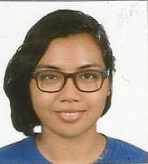**Guevara, Jeri Mae V.**

jerimaeguevara@gmail.com | +63927-240-0856 | Marikina City, Philippines

**Experience**

**Computer Society of the Ateneo**

Ateneo de Manila University, Quezon City

2012-

* I was a promotions head for various CompSAt projects.

**Sanggunian ng mga Paaralang Loyola ng Ateneo de Manila**

Ateneo de Manila University, Quezon City

2013-

* I was part of the promotions team for SOSE Night 2014.
* I am currently a member of the SOSE Department of Internal Affairs.

**Rotary International District 3800**

Marikina City

2012

* I attended their 3-day leadership seminar RYLA held in Antipolo last October 2012.

**Medical Students for Social Responsibility-IPPNW**

University of the Philippines, Manila City

2011

* I won 1st place in their essay writing competition called Tranquills: Writing for Peace.

______________________________________________________________________________

**Skills**

**Knowledgeable in various graphic design software**

* My being promotions head in various CompSAt events have developed my skill in Adobe Photoshop and Illustrator.

______________________________________________________________________________

**Education**

**Marikina Science High School**

High School

2008-2012

**Ateneo De Manila University**

Undergraduate

2012-